Category 2 DSA enhancement report
For category 2 I enhanced the Category 1 c++ to python conversion to also use a hash table. In implementing this I decided to keep the original array as well. The original array is easy to sort and print so I can more easily get an alphabetical listing when needed. The hash table, using Python’s dictionary implementation, is an easier data structure to search.
The worst case for a hash table is O(n) runtime for searching and inserting. However this requires all collisions which would be a poorly designed hash table and data set. In general a hash table is closer to O(1) and is generally considered to be O(1). The worst case for binary search is O(log(n)) and it’s also considered to be the average case as this not only includes situations where it takes the maximum number of iterations to find the target but also for when the target isn’t in the array. For insertion at the end of an array it’s generally an O(1) operation but can be O(n) if the array runs out of space and a bigger one needs to be created. So in general, a hash table should be faster than binary search.
When it comes to memory, hash tables consume additional memory. While Python will in general allocate more space to an array than initially needed to allow for quicker appends, Hash tables tend to be far more over allocated in order to avoid collisions as much as possible. Also hashes, keys, and values need to be stored in the hash table in order for it to work. So while both scale at roughly O(N) the overhead and larger number of slots allocated makes hash tables consume more memory.
Overall, with a program that is mainly meant to search courses and their pre-requisites with the idea that courses would be added once a term and then searched for by students, there is a good use case for hash tables. The need to alphabetically print out a course listing and possibly later adding on the ability to print all MATH### courses gives a good use case for arrays. Therefore, there is a good argument that maintaining both data structures would work well. Extra memory complexity for better runtime complexity.
To support the runtime complexity argument I made performance_test.py. performance_test.py adds Y number of courses to a catalog and chooses courses at random to search for. It then times how long it takes to do a X number of binary searches and X number of hash table searches and reports the time for each value of X and Y chosen. By doing a large number of searches we can eliminate the random factor of getting courses that either favor binary search or hashes. A sample run of Performance_test.py follows:
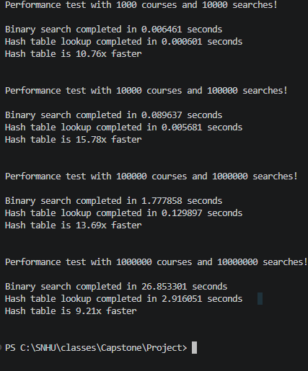
What we see is that at 1000 courses the hash table is 10.76x faster than binary search. At 10000 courses it’s 15.78x faster with 1 million courses hitting 9.21x faster. The likely explanation for binary catching up is that O(logn) is really slow growth at large numbers whereas the hash table is likely experiencing more collisions. For real world data according to Harvard’s FAQ, Harvard has about 3700 courses so it would be somewhere between 10.76x and 15.78x faster to use a hash table. Overall this supports the use of a hash table over an array for something that is likely to be searched often.

REFERENCES
How many courses does Harvard offer?. Harvard College. (n.d.). https://college.harvard.edu/resources/faq/how-many-courses-does-harvard-offer

